**DAILY ONLINE ACTIVITIES SUMMARY**

|  |  |  |  |  |  |  |  |
| --- | --- | --- | --- | --- | --- | --- | --- |
| **Date:** | 30/02/2020 | | | | **Name:** | AMBIKA V | |
| **Sem & Sec** | 4th Sem Section'A' | | | | **USN:** | 4AL18CS005 | |
| **Online Test Summary** | | | | | | | |
| **Subject** | | _ | | | | | |
| **Max. Marks** | | _ | | **Score** | | _ | |
| **Certification Course Summary** | | | | | | | |
| **Course** | Introduction to information security | | | | | | |
| **Certificate Provider** | | | greatlearning academy | **Duration** | | | 5 hrs |
| **Coding Challenges** | | | | | | | |
| **Problem statemen 1:**Write a C Program to generate first n Ugly Numbers | | | | | | | |
| **Status:** completed | | | | | | | |
| **Uploaded the report in Github** | | | | yes | | | |
| **If yes Repository name** | | | | https://github.com/ambika0202 | | | |
| **Uploaded the report in slack** | | | | yes | | | |

**ONLINE TEST DETAILS:N\A**

**CERTIFICATION COURSE DETAILS:**

**Name of the course**: Introduction to Information Security

**Certificate Provider**: Great Learning Academy

Today I have continued a Yesterday topic I.e., Introduction to Information Security .In this course you will be introduced to basic concepts of information security.

**Snapshot:**

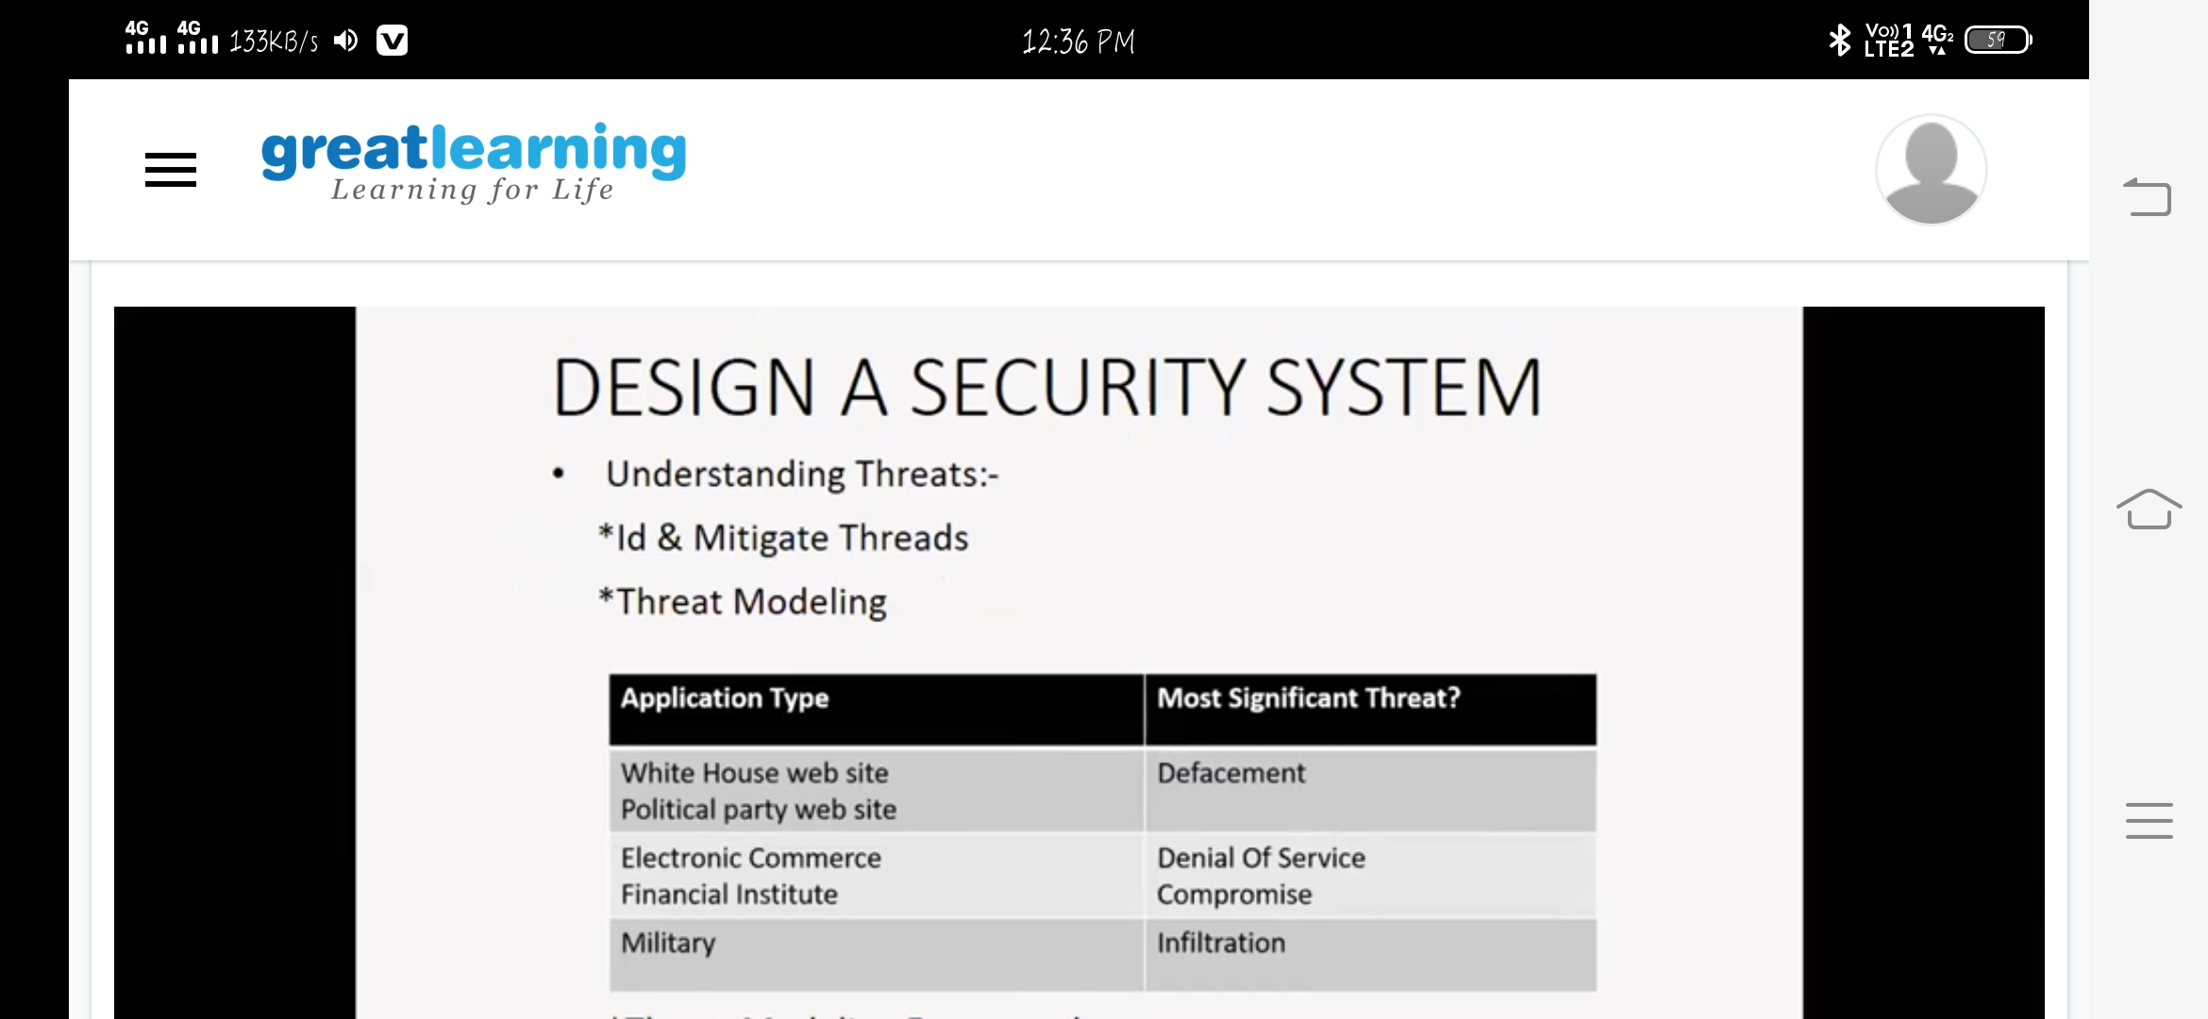

**CODING CHALLENGES DETAILS**: Every day we are given with new question of coding related to the language of java and c.

**Problem statemen 1:**Write a C Program to generate first n Ugly Numbers

**Solution is uploaded in Github**

**Snapshot:**

